Scholastic year 2025/26



PARENTS’ HANDBOOK

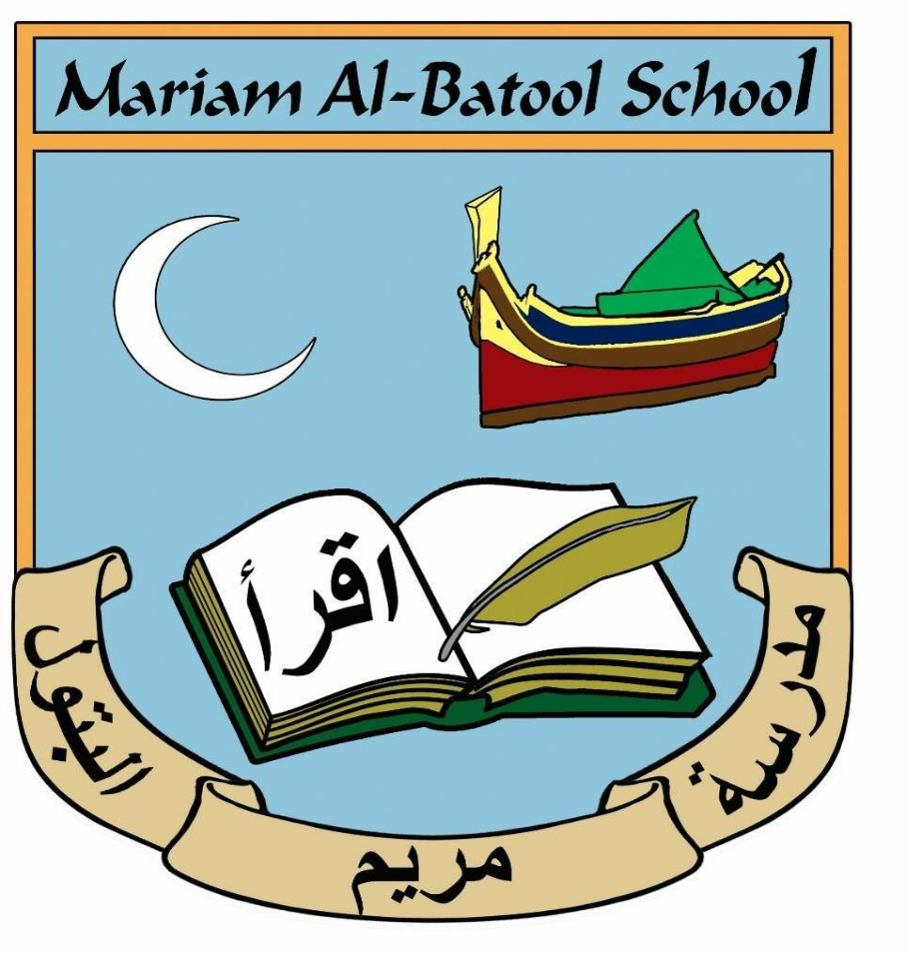

Assalamu Alaikum wa Rahmatullah wa barakatahu

🌟 Welcome to Mariam Albatool School
At Mariam Albatool School, we’re more than just a place of learning—we’re a community. Our independent primary school welcomes boys and girls aged 3 to 11, and we’re proud to offer a safe, caring, and inspiring environment where every child can thrive.

🕌 Faith & Learning, Hand in Hand
We believe that a child’s education should nourish both the mind and the soul. That’s why we combine the Maltese National Curriculum with a strong Islamic and Arabic education. Our goal is to help children grow in their Iman (faith) while building a solid foundation in all academic subjects. From the age of 6, students are encouraged to perform Salaat together, helping them connect spiritually and build a sense of unity.

🌱 Growing Good Character
We place a big focus on spiritual, moral, social, and cultural development. Alongside Islamic values, we help children understand and appreciate fundamental social values, so they can become kind, respectful, and responsible members of society.

👋 A Warm Introduction
We’re so glad you’re considering Mariam Albatool School for your child. We hope their time with us will be full of joy, growth, and meaningful experiences—insha’Allah.
To keep things running smoothly, we’ve put together some guidelines and expectations for parents. This helps us create a positive and respectful environment for everyone. Please take a moment to read through them carefully.
Because we offer a unique blend of academic and faith-based education, we often receive more applications than we can accept. If your child is offered a place, we ask that you support our school’s values and ensure they follow our rules. By joining Mariam Albatool School, you agree to be part of a community that’s committed to excellence, respect, and faith.

🏫 School Uniform Policy
To ensure comfort and consistency, our school has adopted a sportswear-based dress code. All students are expected to wear the designated JOMA MABS sportswear kit every school day.

👕 Uniform Requirements (For Boys & Girls)
Compulsory Items:
- Royal blue JOMA T-shirt
- Navy JOMA jogging trousers
- JOMA tracksuit jacket
- White or black sport shoes
- White or black socks
- One-piece white or grey hijab (if applicable)
Optional Items (Not Mandatory):
- JOMA bermuda (Year 2 students and above should wear bermuda instead of shorts)
- JOMA shorts
- Undervests
- Cotton T-shirt
- Summer cap
- Rain winter jacket
- ⚠️ Important Reminders: Footwear: Only white or black sport shoes are permitted. Students wearing other types of shoes will be considered out of uniform and may not be allowed to attend class.
- Non-compliance: If a student is not in proper uniform, parents may be asked to:
- Provide the correct attire immediately
- Take the child home if necessary
- Occasional Exceptions: A student may be excused from wearing the full uniform only if a written explanation is provided by the parent.
- Jewelry: For health and safety reasons, students are not allowed to wear any jewelry.
🛍️ Where to Purchase:
FULL MARKS SPORTING 📍 288 Triq Haz-Zabbar, Fgura 📞 Tel: 2167726

🏫 School Timing & Drop-Off/Pick-Up Guidelines

⏰ School Hours & Arrival
- School Gates Open:
- Daily at 7:15 AM
- Important: Children arriving before 7:15 AM will be unsupervised, as no staff are on duty before this time.
- School Begins:
- Daily at 7:45 AM
- Students arriving after 7:45 AM will be marked as late.
- Dismissal Times:
| Monday–Thursday | 2:15 PM |
| Friday Only | 11:45 AM |

🚗 Drop-Off & Pick-Up Procedures
- Vehicle Access:
- All vehicles must enter the school premises via the Lower Gate only.
- Do not use the Upper Gate for drop-offs or pick-ups.
- Parking Instructions:
- Vehicles must park in the lower outside yard.
- No vehicles are allowed in the Lower Inner Yard — this is strictly enforced for the safety of all students.

- Pick-Up Times:
- Parents must arrive by 2:15 PM (Monday–Thursday) and by 11:45 AM on Fridays to collect their children promptly.
- Kg students can be picked up from 2:00 pm (Mon-Thurs) and from 11:30 am on Friday.
📝 Arrival & Registration Procedures
- Morning Arrival:
- All children must be ready to enter school by 7:45 AM.
- Students should line up in the playground each morning to be escorted to class by staff.
- Late Arrivals:
- A student arriving after 7:45 AM will be accepted only with an official approval note issued by the school office.
- Without this note, the teacher will not allow the students to attend class.

- Sign-In/Sign-Out Protocol:
- Any child arriving or leaving school outside regular hours must be signed in or out at the secretaries’ office by a parent or guardian.
- This ensures accurate attendance records and supports student safety.

⏰ Lateness
- Pupils who arrive late without a valid or justifiable reason will be marked as unauthorized absent.
- Why Punctuality Matters:
- Children who are persistently late miss crucial learning time—often the most important part of the day—when teachers introduce the day’s objectives and explain expectations.
- Regular lateness can negatively impact a child’s academic progress and disrupt the learning environment for others.
- School Response to Persistent Lateness:
- Parents or carers will receive a formal letter if there are repeated incidents of lateness.
- The school will offer support and guidance to help families address punctuality concerns.
- Continued lateness may result in disciplinary action by the Head of School.

🏥 Illness & Medical Appointments
- Medical Appointments:
- Parents are encouraged to schedule medical appointments outside school hours whenever possible.
- If a child must leave school for an appointment, they should return promptly afterward to minimize lost learning time.
- Reporting Absences Due to Illness:
- The school office or class teacher must be informed on the morning of the first day of absence.
- If the absence continues, parents should update the office each morning.
- Proof of medical appointments must be provided to the office.

✅ Authorized vs. ❌ Unauthorized Absence
- Present – The child is marked present when the student is physically present at school.
- Excused (Justified) Absence – Absence considered justified if:
- A written note or email or call from the parent is provided for up to 3 days a month. Upon review and acceptance of the reason, the child will be marked as being excused.
- For travel a copy of the flight tickets are required
- Other valid reasons (family emergencies etc.) may be accepted if approved by the Head.
- Unjustified Absence – Marked as absent if:
- No valid reason is provided
- The student is absent for more than three days a month without approval from the Head of the school.
- The student returns to school after illness without a medical certificate

- Medical Absences:

- Following any absence due to illness, a child must present a medical certificate stating the date they are fit to return to school.
- Without a valid certificate, the child will be marked as absent and will not be allowed in the classroom.

- Short-Term Personal Absences:

- If a child is absent for less than three days a month due to personal reasons or feeling unwell, parents may request an Absentee Form.
- The form must include a clear explanation for the absence.

- Absentee Forms:

- These forms are available from class teachers, who will keep copies on hand. A printable copy is also available on the school website.

⚠️Important: justified absences are only accepted for up to 3 days a month. If a student is habitually absent (3+ days per month) the Education Psycho-Social services may be involved.

👧 Behaviour Expectations

At MARIAM ALBATOOL School, we uphold the highest standards of behaviour for all students. We believe in fostering a positive environment and will be introducing awards throughout the year to recognise children who consistently demonstrate excellent behaviour.
- Zero Tolerance for Aggression:
- Aggressive or violent behaviour is not tolerated under any circumstances.
- Any child exhibiting such behaviour will be called to reflect on their actions and consider how to behave appropriately in the future.
📞 Emergency Contacts
- Parents/guardians must provide the school with two up-to-date emergency contact numbers.
- It is essential that we are able to reach you at any time during school hours.
- Insha’Allah, we hope no emergency will arise. However, should it so happen, and the contact information provided is incorrect or outdated, you will be held responsible for any additional distress caused to your child.
- Change of Address:
Any changes to your home address must be reported to the school immediately.

🤒 Collecting Sick Children
- If you are contacted to collect your child due to illness or any other urgent reason, you must arrive promptly.
- We do not make such calls lightly, and we expect you to either:
- Collect your child yourself, or
- Arrange for a trusted friend or relative to do so.
- If someone else is collecting your child:
- You must provide the ID card number of the person.
- The child will be released only upon presentation of a valid Identification Card.

🤒 Illness
- If your child is unwell, do not send them to school.
- They should remain at home to rest and recover or be taken to a doctor if necessary.
- If your child has a contagious illness or virus, attending school puts other children and staff at risk.
For this reason, any child who appears visibly sick or ill will not be allowed to attend school.
🩹 First Aid
- Minor accidents may occur during the school day.
If your child is involved in an incident and receives first aid, it will be recorded, and you will be notified via message or phone call.
- In the case of a serious injury, the school will contact you immediately and to collect your child to be seen by a medical professional.
💊 Medicines
- The school is not permitted to administer medication of any kind.
If your child requires medication during school hours, please consult with the school office to discuss appropriate procedures.

📚 School Books
- All students are expected to have all required textbooks listed in the official booklist provided to current students.
- Photocopying textbook pages is not allowed.
If a student does not have the necessary book, they will be unable to follow lessons or complete school/homework.
📖 Islamic & Arabic Books
- Islamic and Arabic books are available for purchase from the secretaries’ office.
- Only students who have:
- Settled full payment for the 2024/25 scholastic year, and
- Paid the deposit for the 2025/26 scholastic year
are eligible to buy these books.
- Cost:
- €10 per book
- Levels 1–3: 4 books total (3 Arabic Language, 1 Islamic Studies)
- Levels 4–6: 3 books total (2 Arabic Language, 1 Islamic Studies)
🏷️ Book Care & Labeling
- All books and copybooks must be covered and clearly labeled with the child’s full name.
- For Islamic/Arabic books, please note:
- These books open from left to right, so the label must be placed on the back cover.
- The school is not responsible for any missing books that are not properly labeled.

📘 Homework Policy
At MARIAM ALBATOOL School, homework is an important part of reinforcing classroom learning and developing independent study habits.
- Years 1–6:
- Homework is assigned at the teacher’s discretion.
- Wednesday is a no-homework day, unless the teacher determines that a student should use the time to catch up on missing work.
- Homework Expectations:
- All assigned homework is required.
- It is the parents’ responsibility to ensure that homework is completed and returned on time.
- Parents are encouraged to check out their child’s school bag daily, as some children may claim there is no homework—even when it has been posted on Microsoft Teams. This is often not accurate.
- Failure to Complete Homework:
- If a child fails to complete and return two consecutive homework assignments or three non-consecutive assignments, parents will be required to meet with the teacher to discuss the issue and find a solution

🗣️ Complaints Procedure
At MARIAM ALBATOOL School, we strive to ensure every child has a successful, enriching, and rewarding experience. However, we understand that concerns may occasionally arise.
- If you are dissatisfied or have a concern, we encourage you to speak directly with your child’s class teacher or a member of the administrative staff.
You can contact the administration on their respective emails:
Mr Brian Vassallo: b.vassallo@mariamalbatool.com
Ms Debbie Atanasio : d.atanasio@mariamalbatool.com
Ms Diana Salerno : d.salerno@mariamalbatool.com
- Our team is available most of the time and will do their best to listen, understand, and resolve any issues promptly and professionally.
Open communication between parents and staff is key to maintaining a positive and supportive school environment.

🥪 Packed Lunches & Snacks
At MARIAM ALBATOOL School, we encourage healthy eating habits to support your child’s learning and well-being.
- Packed lunches should include nutritious food and drinks.
- Please avoid sending crisps, sweets, or fizzy drinks.
- Water, fruit, whole grains, and balanced meals are strongly encouraged.
- Important Notes:
- Food cannot be reheated at school — please do not request this.
- Children should have a healthy and filling breakfast at home before arriving.
Snack time is not intended to replace breakfast.

🌟 Special Educational Needs (SEN)
At MARIAM ALBATOOL School, we are committed to supporting every child’s individual learning journey.
- Our SEN policy is based on early identification, followed by regular monitoring and assessment.
- When necessary, an Individual Education Plan (IEP) will be developed to support the child’s specific needs.
- Parents are fully informed at every stage and are invited to participate in discussions regarding their child’s IEP.
- Every child is valued equally and given the same opportunity to thrive.

👨‍👩‍👧 Parents’ Days
- Two Parents’ Days are held each year to provide parents with a detailed update on their child’s progress:
- One in the autumn term
- One in the spring term
- Additionally, we host Meet the Teacher Mornings at the beginning of the first term to foster early communication and collaboration between parents and teachers.

🗓️ Orientation Meetings
- Orientation meetings between parents and teachers take place at the start of each scholastic year.
- A detailed schedule of meetings will be shared with parents in September.
- It is important that all parents attend, as these meetings set the foundation for a successful school year.

💳 ALBATOOL School Fees Policy
MARIAM ALBATOOL School is proud to offer affordable tuition without compromising the quality of education. Below is our updated fees policy for the scholastic year.
📌 General Guidelines
- School fees are payable even if your child is absent due to illness or other personal reasons.
- If you intend to withdraw your child from school, you must provide at least one month’s notice.
- Failure to do so will result in fees being charged for the full term.
- A one-time, non-refundable registration fee of €300 is required upon admission.
- Additional charges may apply for school trips and activities. Parents will be notified in advance.

🏫 Annual Tuition Fees
Level | Annual Fee | Sibling Discount (for Options 1 & 2 only)
Kindergarten | €1,665 | 10% off per sibling
Primary | €2,010 | ` 10% off per sibling
💰 Payment Options
Option 1: Full Year Payment
- Pay the full annual fee in September.
- Receive a €50 credit as a benefit.
Option 2: Termly Payments

- Pay in three installments:
- Kindergarten: €555 per term
- Primary: €670 per term

Term | Due Date
1st Payment | 1st week of October
2nd Payment | 2nd week of January
3rd Payment | 1st week of April

Option 3: Monthly Payments (Sibling discount does not apply with this option).

- Pay in nine monthly installments from October to June:
- Kindergarten: €185/month for 9 months
- Primary: €255/month for 9 months
- Payable 1st week of every month

🏦 Bank Transfer Details
- You may choose to pay via our Revolut account or BOV mobile to mobile transfer on:
- If you choose to pay via bank transfer, please provide a copy of the transaction to the school office.
Bank: Bank of Valletta
Branch: 212/215 Marina Street, Pietà PTA 9041, Malta
Account Name: MABS
Account Number: 40010083035
IBAN: MT7VALL22013000000040010083035

📅 First Day of School – Scholastic Year 2025/20256
The first day of school for Primary students will be:
🗓 Wednesday, 24th September 2025
- KG1 students will begin in small groups of 5 starting from 29th September to ensure a smooth and supportive transition.
- A detailed list of classes and commencement dates will be shared with parents at the beginning of September.
- A copy of the school calendar will also be sent to you.
Please keep an eye out for updates and ensure your child is prepared for a positive start to the new school year.

📘 Closing Remarks

Please keep a copy of this handbook in a safe place for future reference, as it contains essential information regarding school policies and procedures.
We kindly ask that you read the guide thoroughly. The school will not accept claims of unawareness regarding any content outlined in this document. relevant authorities. The information provided may be subject to change if deemed necessary by the school's administration.
Jazaakumullahu Khairan for your cooperation and continued support.

Warm regards,
Ms. Simone Palmier Arab
On behalf of the School Administration

School contact information : 21664791
info@mariamalbatool.com

